**Toronto COVID-19 Cases, Crime, and Venues Data Analysis**

Saifullah Qasim

August 25, 2020

**1.Introduction**

* 1. **Background**

Toronto is the fourth largest city in North America and the largest metropolitan area in Canada with an estimated population of 6.4 million, and a labour force of more than 4.7 million. There are over 800,000 businesses in the area and 38 percent of Canada’s businesses are headquartered in the city. It has a massive economy, comprising of $332 billion and is the third largest tech sector, second largest financial center, and second largest food and beverage industry in entire North America [1].

It has one of the best educational institutes in the world and contains five world renowned universities along with six internationally recognized colleges. It is a city that is constantly evolving with over 100,000 immigrants arriving yearly, bringing with them a wide variety of skills and technical expertise. It includes a wide variety of unique venues that are catered to its diverse population that speaks over 180 different languages and dialects [1].

* 1. **Problem**

Big metropolitan areas present enormous opportunities for entrepreneurs, skilled workers, and families seeking a better life and education for their children. Factors of stability are of great importance for people that would be considering immigration or investing in the city. Apart from crimes, the onset of COVID-19 has presented the world with its unique challenges.

This report will focus on providing a crime and school analysis to provide insight for families and education seekers. COVID-19 cases and infection sources in the Toronto area will also be highlighted to provide insight to individuals and corporations alike.

**2. Data Acquisition and Cleaning**

**2.1 Data Sources**

Several sources were used for data collection. Toronto Borough, Neighbourhood, and Postal Code data was scraped from Wikipedia [2] while the geographical coordinates of each Postal Code were downloaded from Coursera e-learning portal [3]. Major crime indicators and homicide data was downloaded as a csv file from Toronto Police open data portal [4][5]. The Toronto open data portal was utilized for collecting COVID-19 cases and school locations data in the form of a csv file [6][7]. The geographical coordinates of each postal code were utilized to collect venues data within 800 m radius using Foursquare API.

**2.2 Data Cleaning**

The Toronto Borough, Postal code, and Neighbourhood data was cleaned to remove rows with unassigned values. It also contained one neighbourhood for Mississauga which was removed. The data frame was then merged with the geographical coordinates file to include Neighbourhood, Borough, Postal Code, along with Longitude and Latitude values.

The Foursquare API was used to collect venues based on the geographical coordinates of each neighbourhood. The major crime indicator and homicide data were obtained separately and were merged for the year 2019. Another data frame was created with the total number of crimes for each neighbourhood in order to create a choropleth map utilizing geojson file for the city of Toronto. Unassigned and unspecific values were removed to reveal specific crime analysis insights for the City of Toronto.

The COVID-19 cases data was cleaned to remove rows containing unassigned values. Once the data cleaning was accomplished, the data was then analyzed to reveal strategic insights.

**3. Design Methodology**

**3.1 Toronto Venues, Neighbourhoods, and Boroughs**

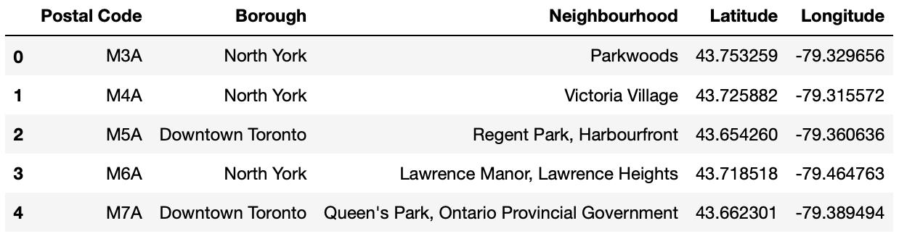The full code can be accessed on my GitHub repository along with the final report. The Neighbourhood, Borough, Postal Code, and geographical coordinates data frame is as follows:

North York, Downtown Toronto, and Scarborough contained the highest number of neighbourhoods. A neighbourhood breakdown based on each Borough/Sub-Borough for Toronto is visualized through the pie chart as shown below:

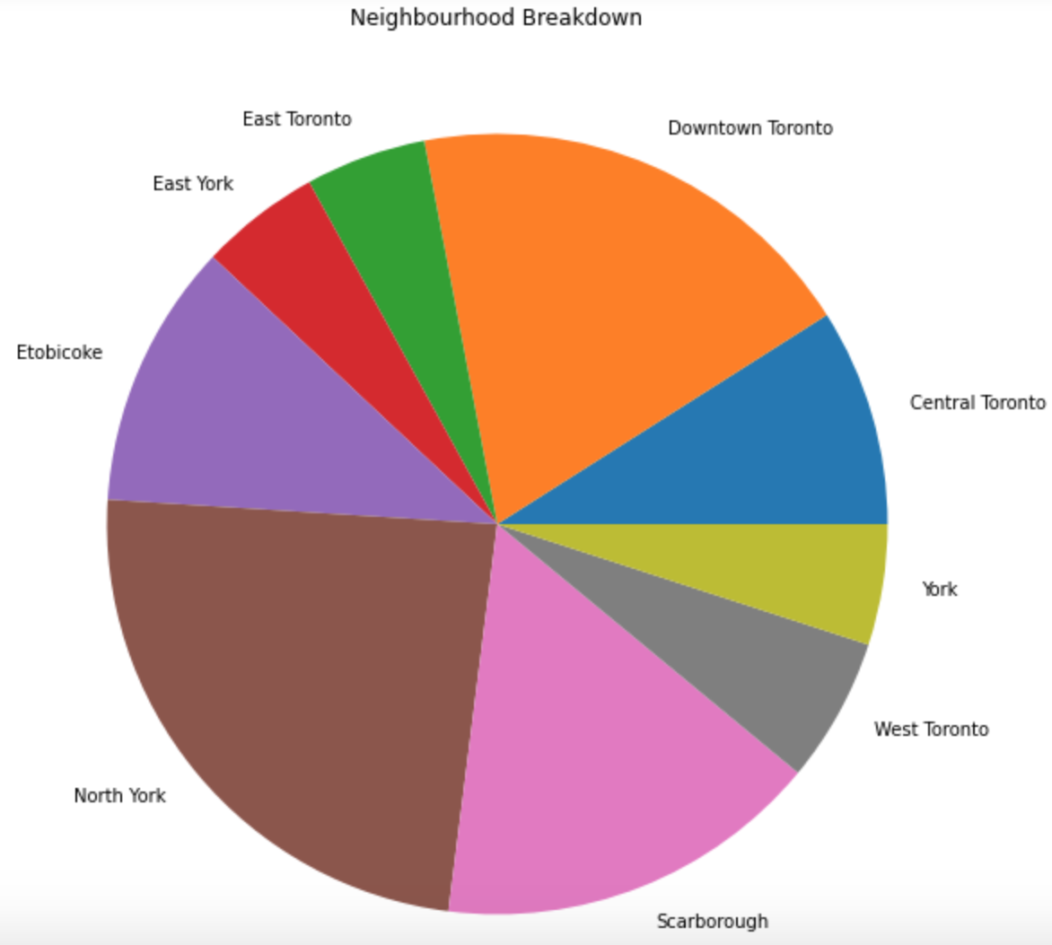

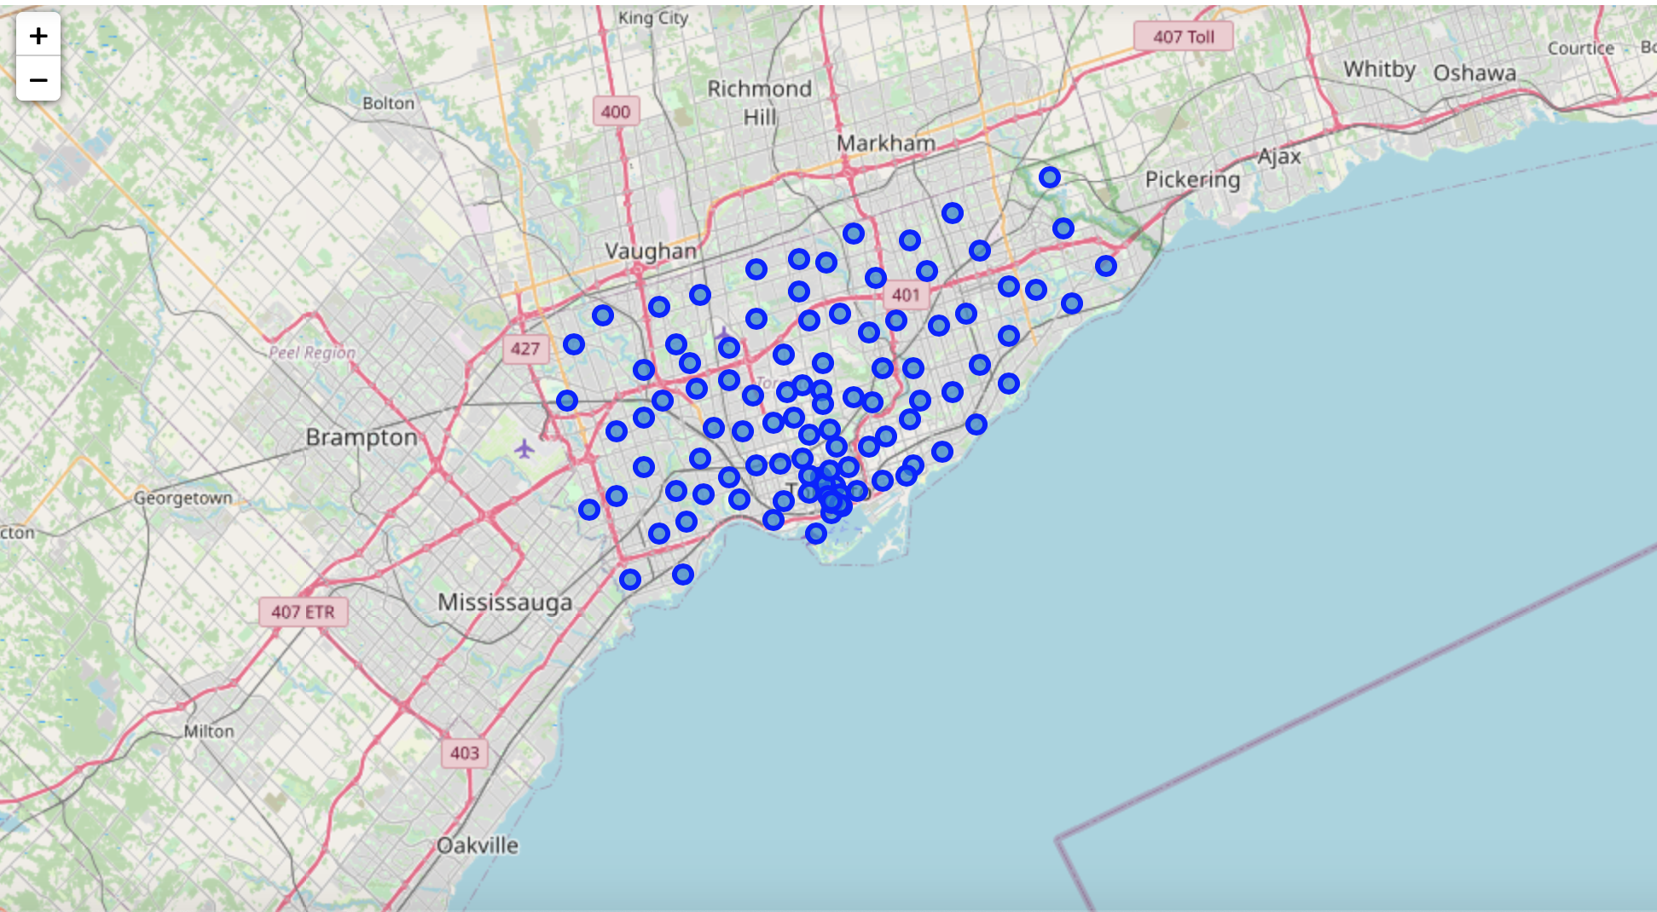Folium map in Python was used to visualize the neighbourhoods superimposed on the Toronto city. The longitude and latitude values of each Postal Code were used to create markers. Foursquare API was then used to acquire the venues locations within an 800-meter radius from each neighbourhood’s geographical coordinate. The venues limit was set to a max value of 100. A total of 3898 venues were found with 333 unique categories. The following data frame was obtained:

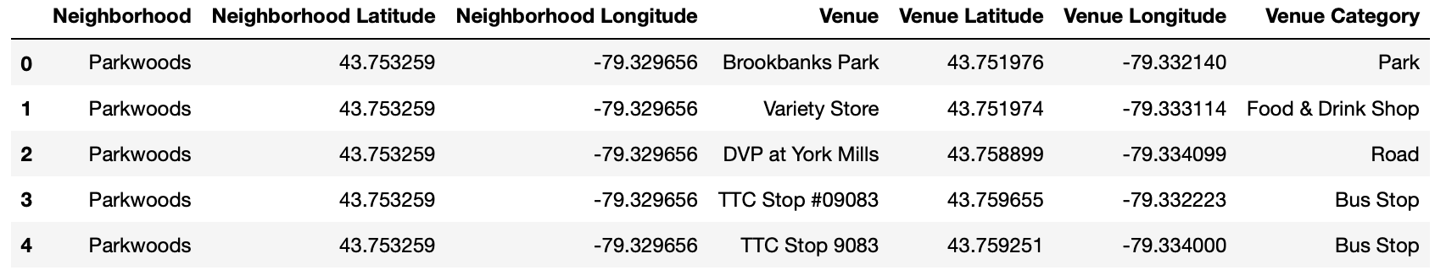

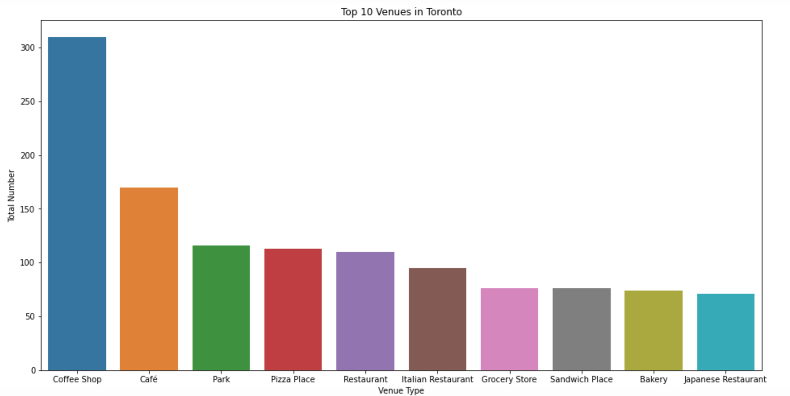Coffee shop was the most common venue, followed by Café and Park. Pizza Place, Restaurants, Grocery Store, and a bakery were also among the top ten venues. A bar plot was obtained to visualize the venues.

A data frame table was also created containing top ten venues for each neighbourhood as shown below:

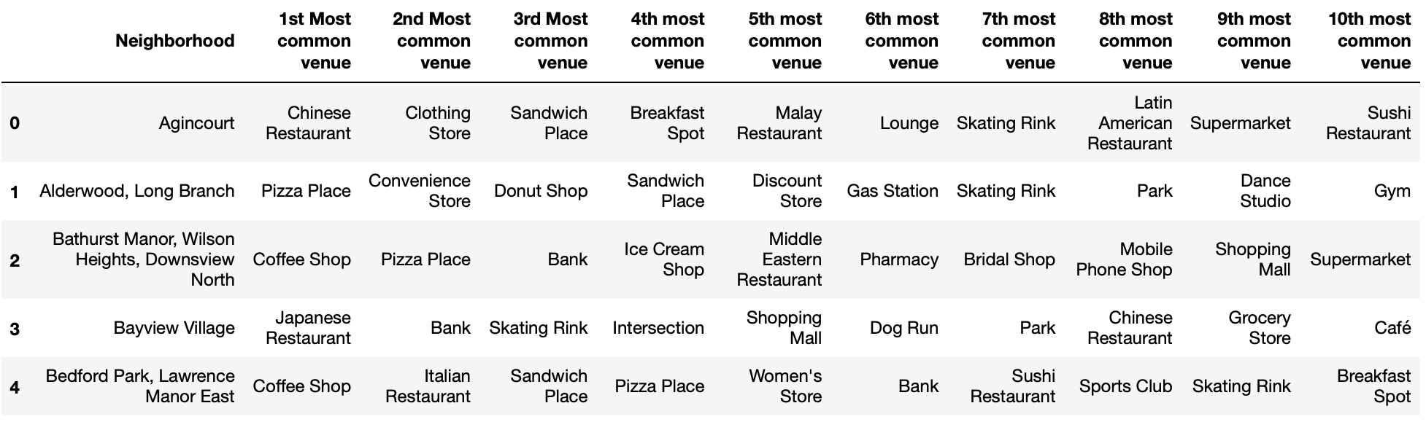

KMeans unsupervised machine learning method was used to cluster the venues. The Elbow method was utilized to find the optimal number of clusters. The optimal number of k was determined to be 3 as shown by the following graph:

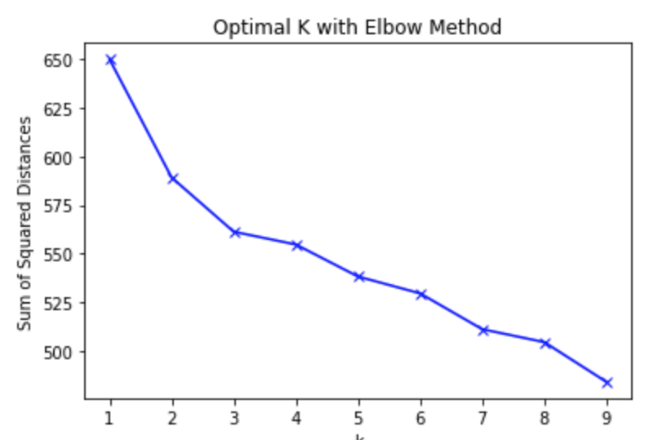

Once the optimal number of clusters was determined, it was applied to the Toronto venues list to separate the venues into three distinct clusters. The venue clusters were then visualized through folium map as shown below:

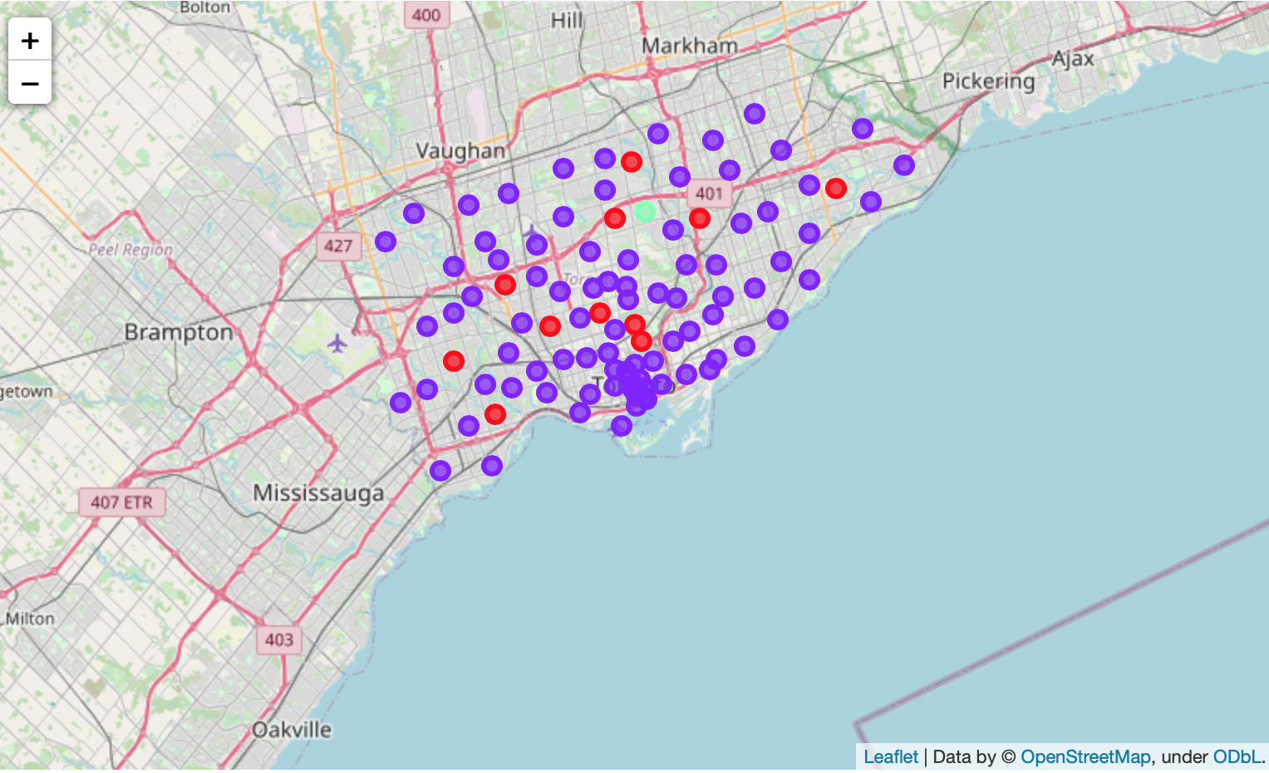

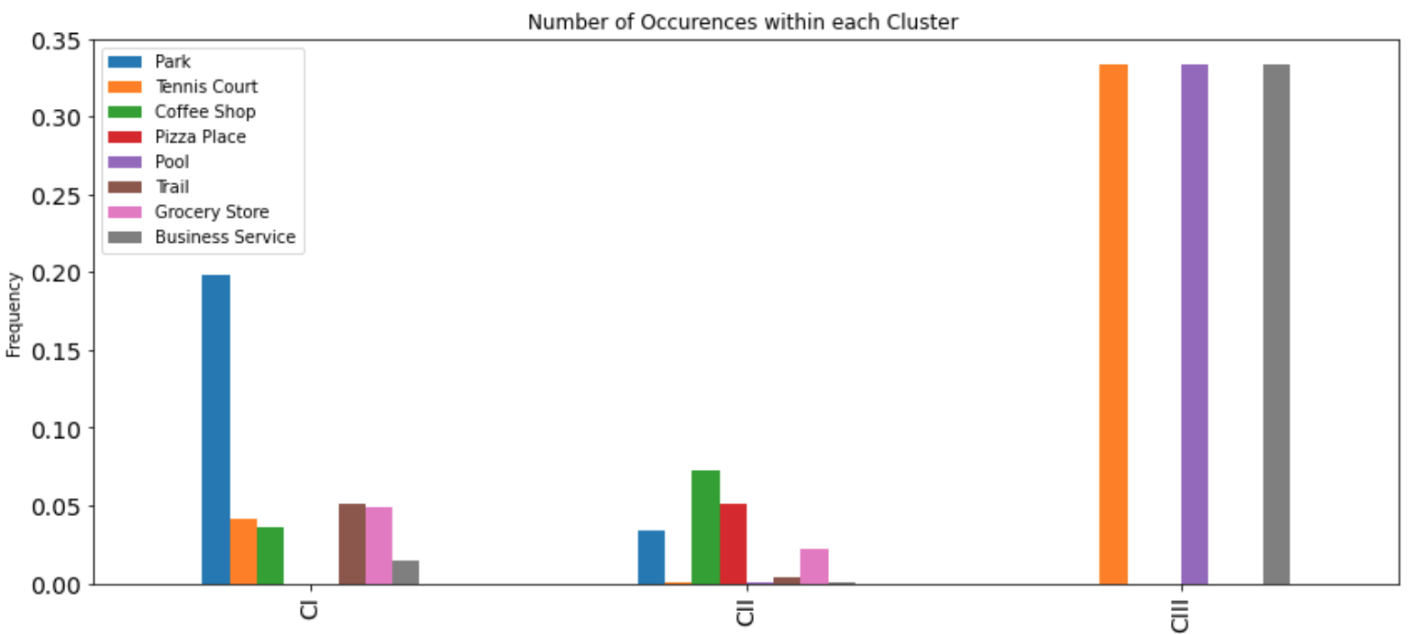Each cluster venues were then analysed to further reveal the unique venue categories. Cluster I, colored red in the folium map above, has a moderate number of markers while Cluster II (purple) have the most markers. Cluster III (green) appears to be the most unique with only one marker. A bar plot was utilized to visualize the venue categories and their frequency within each cluster.

Park venues have the highest frequency in Cluster I, while Coffee Shop venues, followed by Pizza Place venues have a high frequency in Cluster II. Both Cluster I and II contain grocery store venues which indicates populated residences. Cluster III is the most unique cluster of venues and contains Tennis Court, Pool, and Business Service venues. These venues are indicators of a well-developed area with a high concentration of upper-class gentry.

**3.2 Toronto Crime and School Analysis**

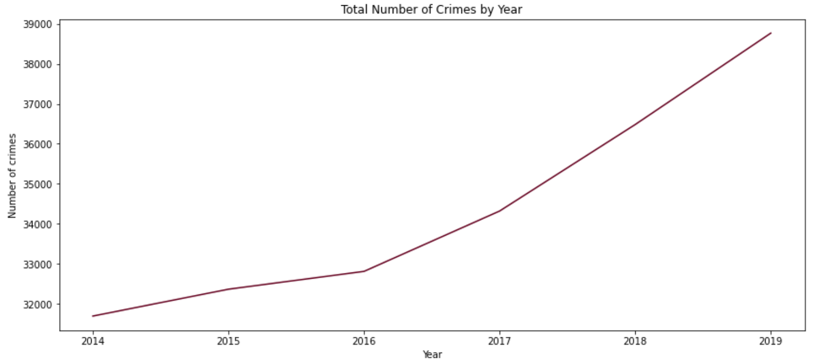Total number of reported crime cases were counted from the year 2014 to 2019. The total number of crimes during these years were visualized as follows:

As the above figure suggests, Crime cases have been increasing at a linear rate from 2014 and onwards. There is a sharp rise in crime cases after the year 2016 with a continuous increase till the year, 2019.

Homicides in Toronto consisted of Stabbing, Shooting, and unnamed category type. The unnamed category homicide was not included in the analysis due to its non-specific nature. There were a total of 44 Shooting and 16 Stabbing incidents for the year 2019. The folium map with a CartoDB dark matter tile style shows the homicide locations in Toronto. Red colored markers are shooting crimes while orange color represents stabbing events.

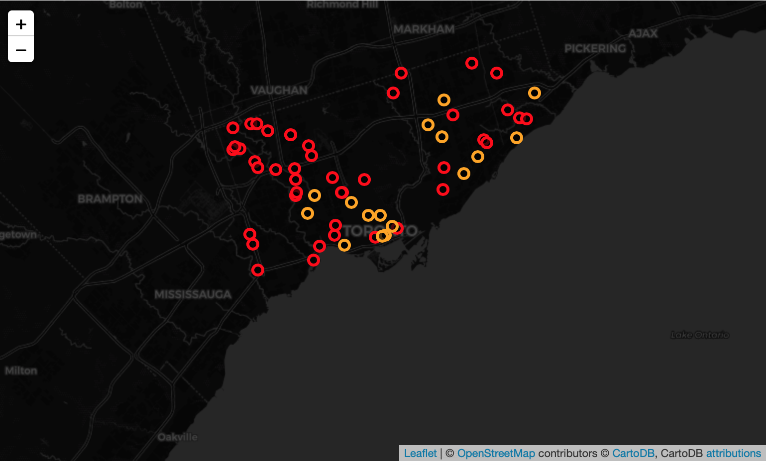As evident from the homicide map above, most of homicide events occurred in the west end of Toronto. The homicide crimes on east Toronto appear to be more dispersed throughout. Central Toronto appears to have no homicide markers.

The total number of crime cases were calculated for the year 2019 for each Neighbourhood in Toronto. The top ten neighbourhoods with the highest crime rates in Toronto are as follows:

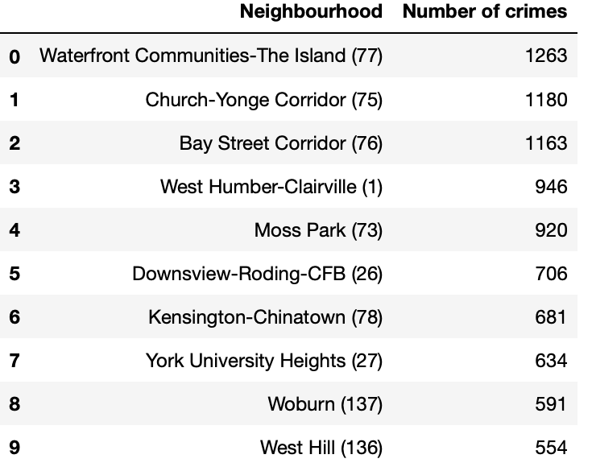

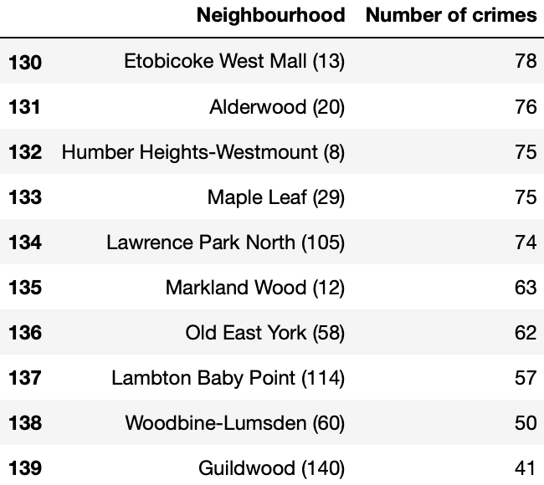The ten neighbourhoods with the lowest crime cases in Toronto are as follows:

A choropleth map with CartoDB positron tile style was created to visualize and classify high and low crime areas for the entire city of Toronto.

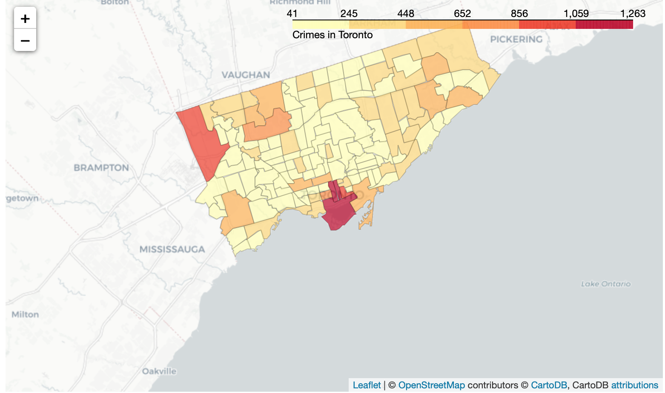

The venue clusters were superimposed as markers on the choropleth map to provide crime insight near venues.

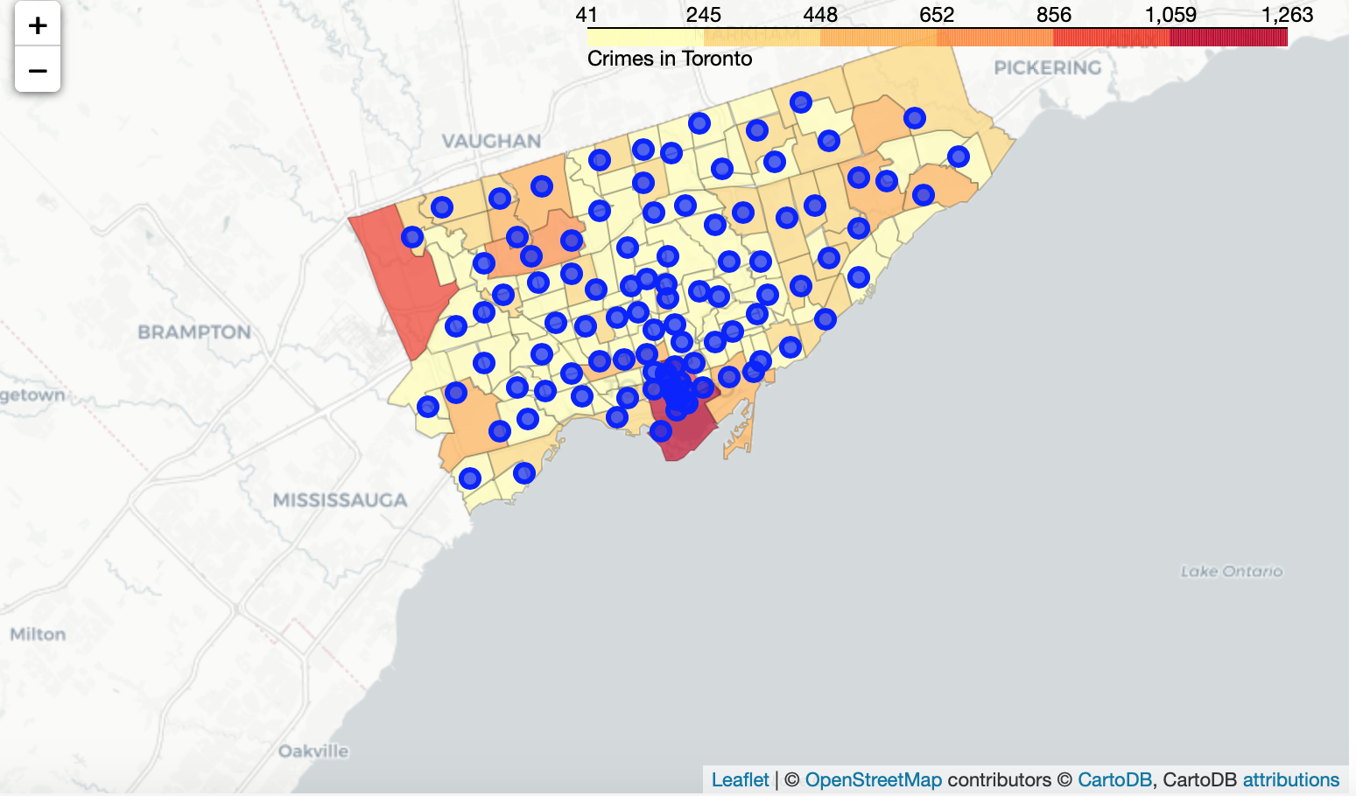

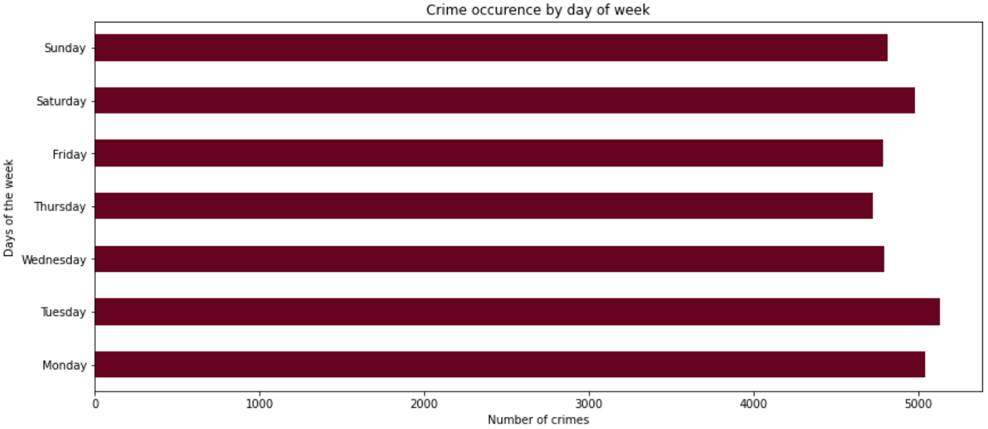The crimes by day of the week were analyzed through a horizontal bar plot.

The total number of crimes are dispersed throughout the days of the week. Tuesday has the highest number of crimes while Thursday has the least number of crimes, although the crime variation between the days of the week is marginal. The correlation between months of the year and total number of crimes were also analyzed.

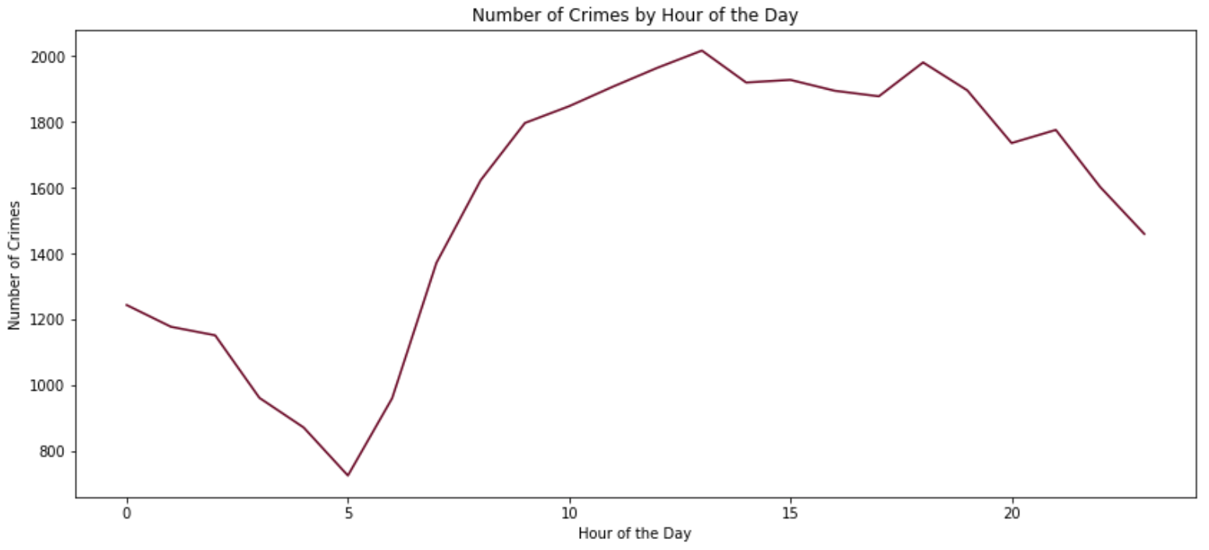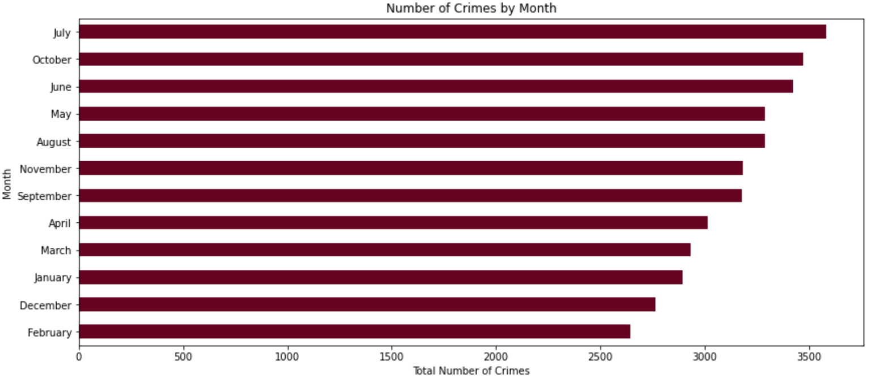July appeared to have the highest number of crimes followed by October. February and December registered the lowest and second lowest crime rates, respectively. Crime and hour of the day correlations were studied through time series analysis.

Crime was at its lowest around 5am and highest during afternoon hours of 1 and 6 pm. These findings could greatly help law enforcement and city agencies, businesses and individuals for strategizing their crime reduction activities.

The type of offenses in Toronto were also visualized through a horizontal bar plot as shown below:

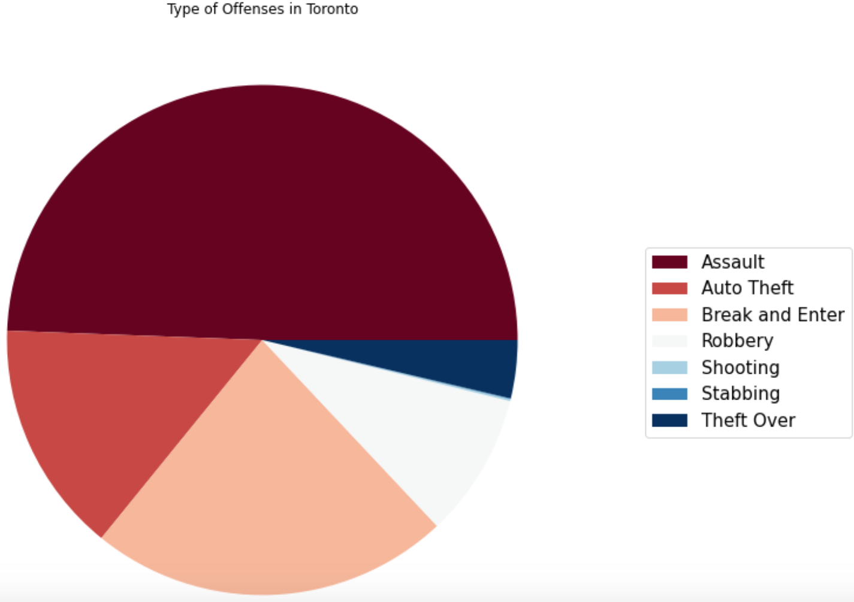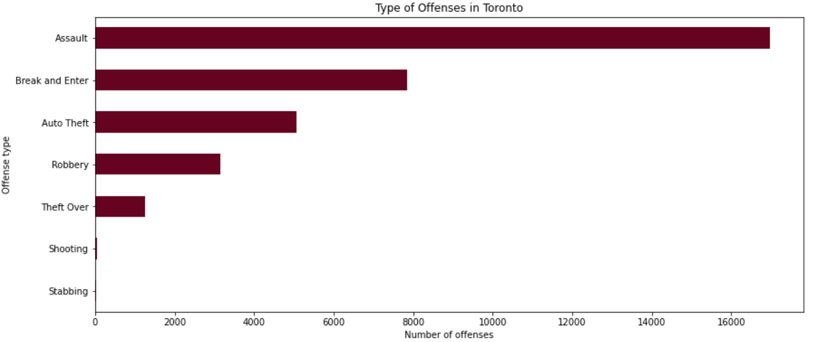Assault is the most common type of offense followed by Break and Enter. Fortunately, Shooting and Stabbing related offenses are the least common having a combined total of less than 100. The offense breakdown can be further understood through the following pie chart:

Assault comprises of about 50 percent of all crimes in Toronto for the year 2019. Break and Enter and Auto theft were the second and third most common type of offence, respectively. The location of the offences was also analyzed as shown below:

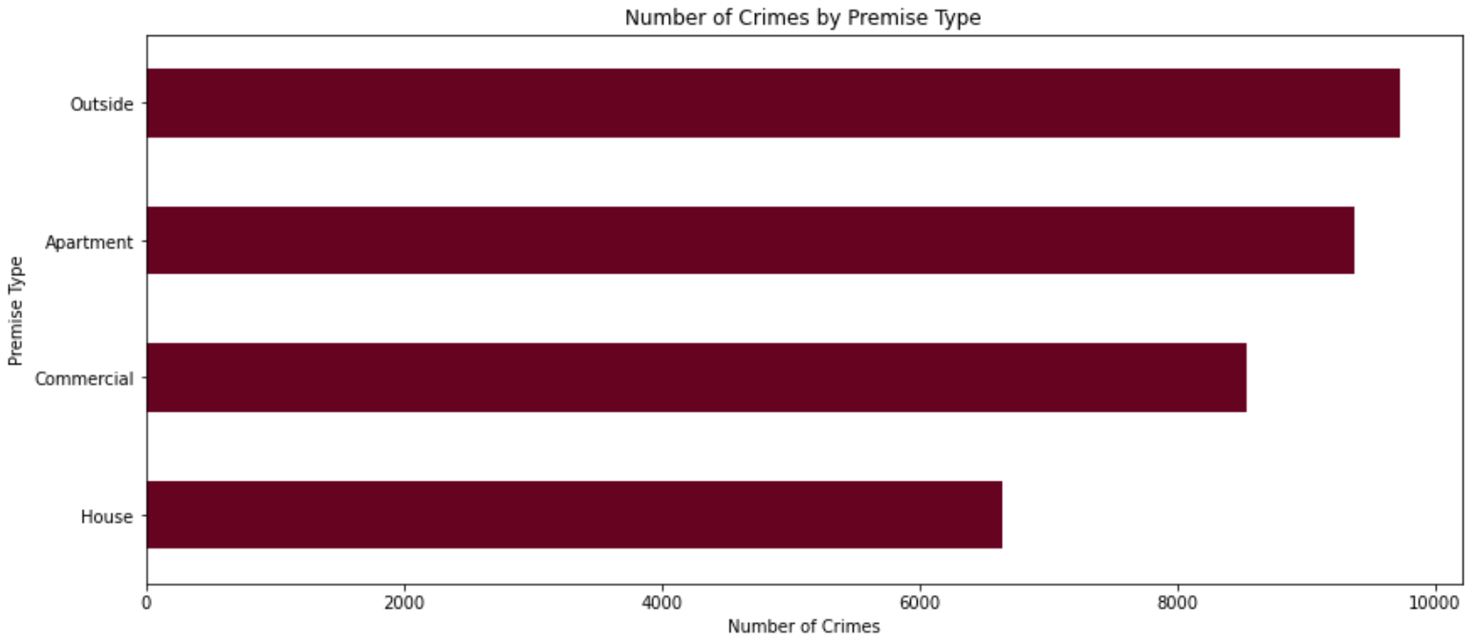The highest number of crimes occurred in outside space followed by apartment locations. Houses had the lowest number of crime occurrences, perhaps it could be due to the added safety of the house or a high socio-economic status or education of its inhabitants. More research is needed to determine the reason behind these findings.

The relationship between the type of crime and crime premise was analyzed through multi-plot grids using Facet Grid in seaborn, as shown below.

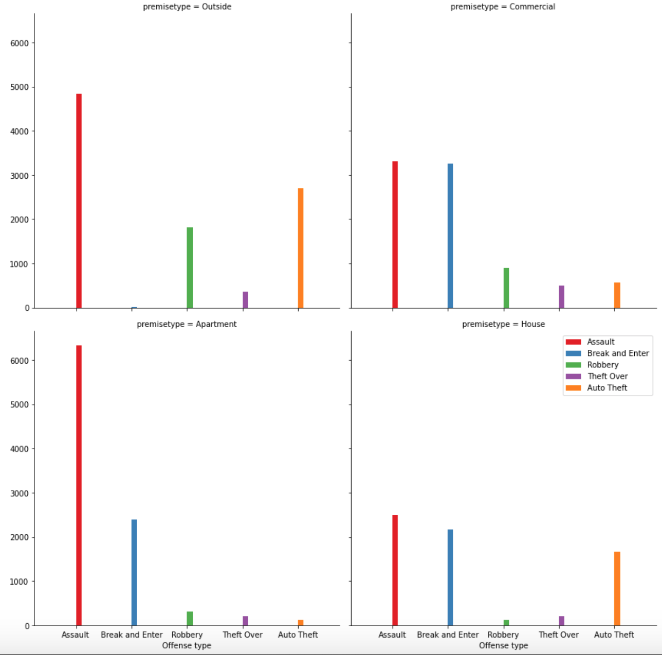

The multi-plot grids provide beneficial insights for type of crimes in different premises. Assault was the most common offence type in all premise types. Apartment locations had the highest proportion of assault offence occurrences. Perhaps this could be due to a high population density or the socio-economic status of residents. Another reason for this finding could be due to the scarcity of resources and the increased competition for these resources between inhabitants. More research is needed to determine the exact causes for these occurrences.

Break and Enter offences were the second most common type of offences in commercial and house locations, although, it’s difference from the most common offence was marginal. Perhaps this could be due to the presence of high valued goods that could provide the motivation to a crime doer.

It’s a well-known fact that education plays an important role in the growth of economy. A list of educational institutes within the boundaries of Toronto were analyzed. A folium map was utilized to map out the different educational institutes on a choropleth map with crime rates, as shown below.

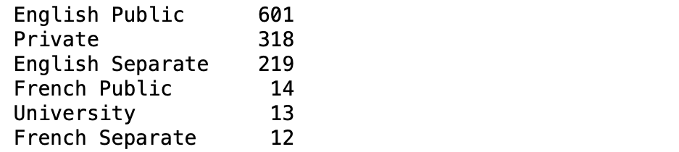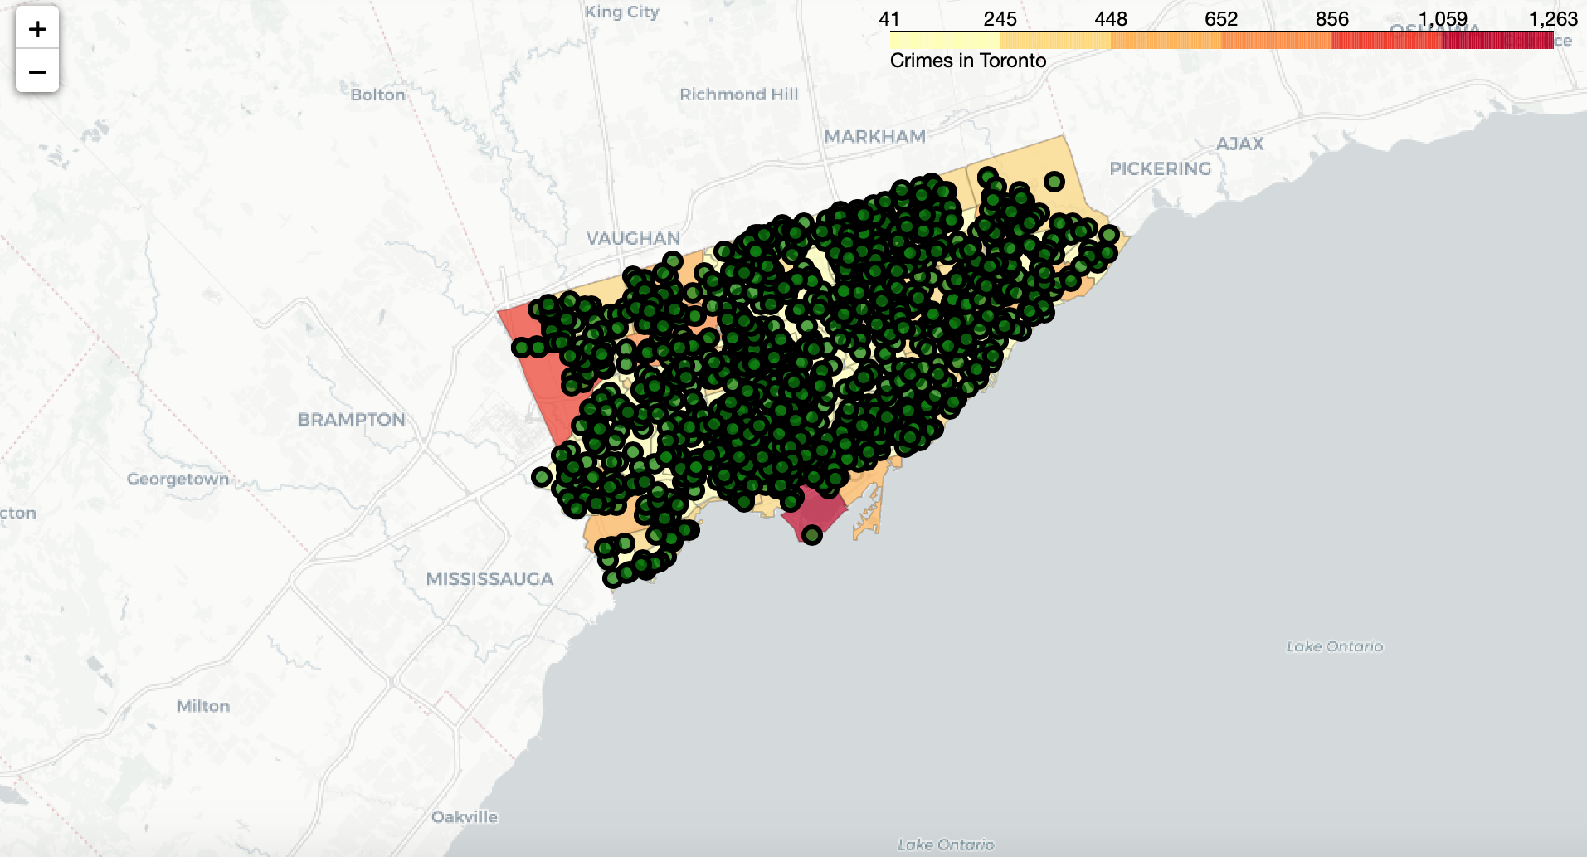The unique type of educational institutes were determined through the value counts function in Python, and can be seen below.

French and English are the official languages of Canada. As being bilingual can open up more employment opportunities for individuals, it can be useful to become fluent in both of these languages. Therefore, Universities, French Separate and French Public schools were visualized on the crime rate choropleth map to assist with decision making when selecting an educational institute with low crime occurrences.

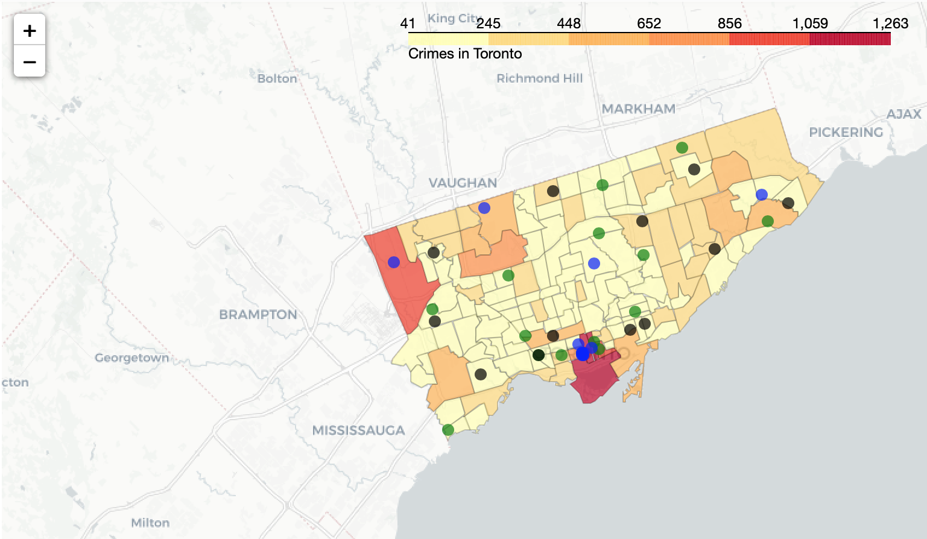Different color markers were selected to distinguish between type of institutes. Green markers are for French Public Schools, Black for French Private Schools and Blue for Universities. Educational institutes that are marked in yellow areas in the above map are located in areas where crime is the lowest.

Whether it’s individuals interested in buying their next house, selecting an educational institute for themselves or their children, or a business/investor considering buying a property, A wide variety of stakeholders could benefit from this information. Police and City Officials can also benefit from these insights to better manage the city.

**3.3 Toronto COVID-19 Cases**

With the onset of a global pandemic, the year 2020 has presented the world with unique challenges. COVID-19 has affected a wide variety of governmental agencies, programs, businesses and individual lifestyles. The COVID data was collected from the city of Toronto’s open data portal and aims to provide stakeholders with meaningful insights to assist with decision making.

Females had a higher rate of infection in comparison to males as seen by the horizontal bar plot shown below.

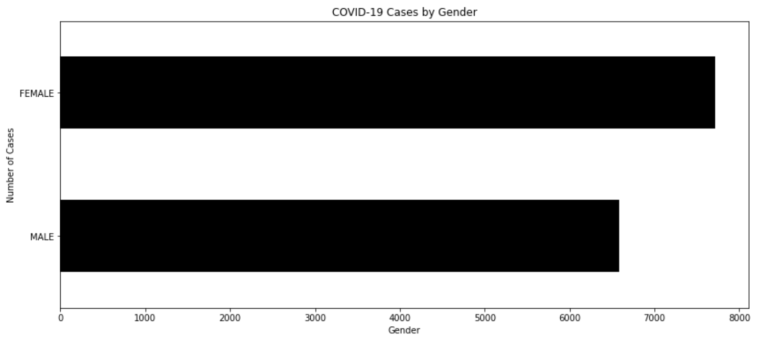

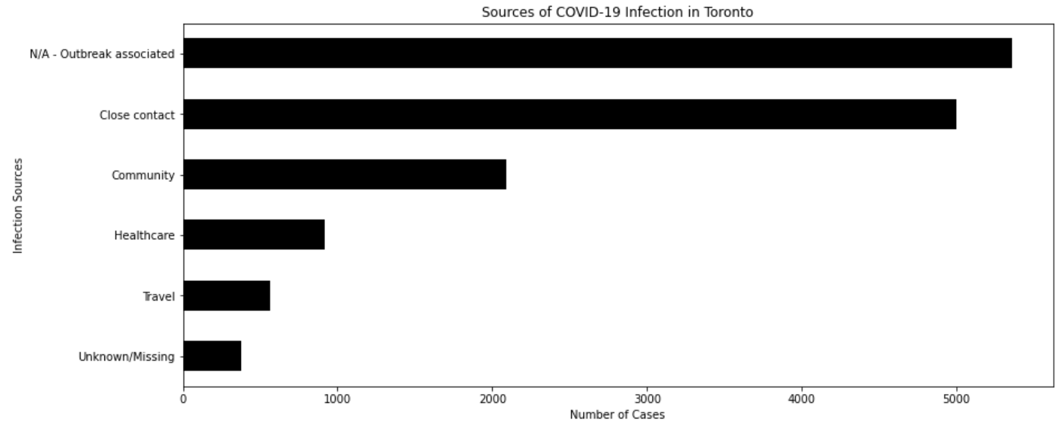Sources of infection were analyzed. Majority of infections occurred were outbreak associated followed by close contact as highlighted by the graph below.

Sources of infection and gender were grouped together and visualized through a Facet Grid, as shown below.

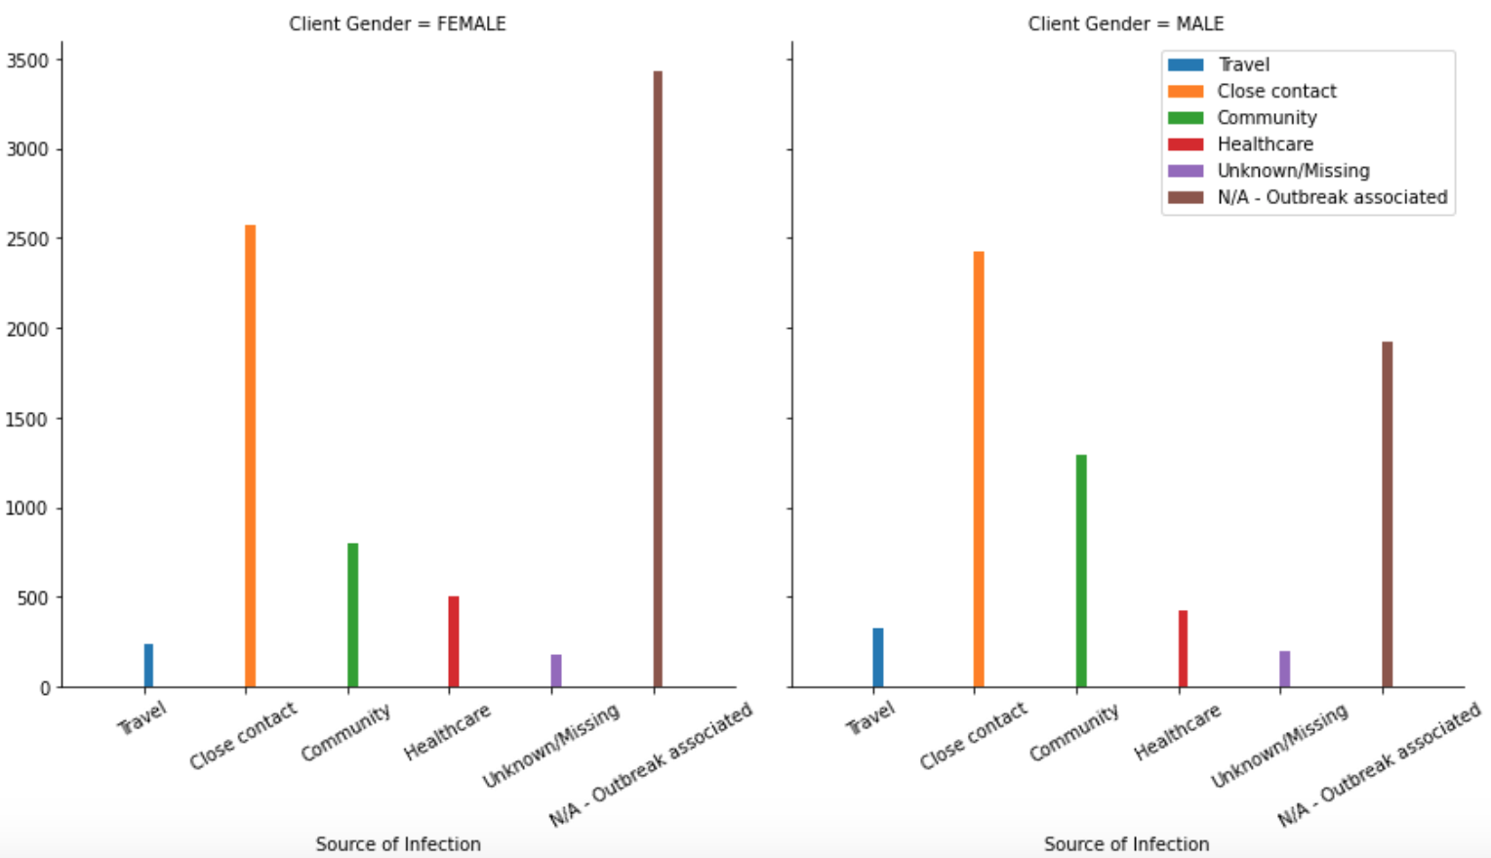Most common source of infection for females was outbreak associated, while for males it was close contact.

COVID cases were grouped by age group to understand the most commonly affected age group within Toronto. 50 to 59 year olds were the most prone to infection followed by 20 to 29 year olds. Individuals 19 and younger had the lowest rates of infection, as can be seen in the graph below.

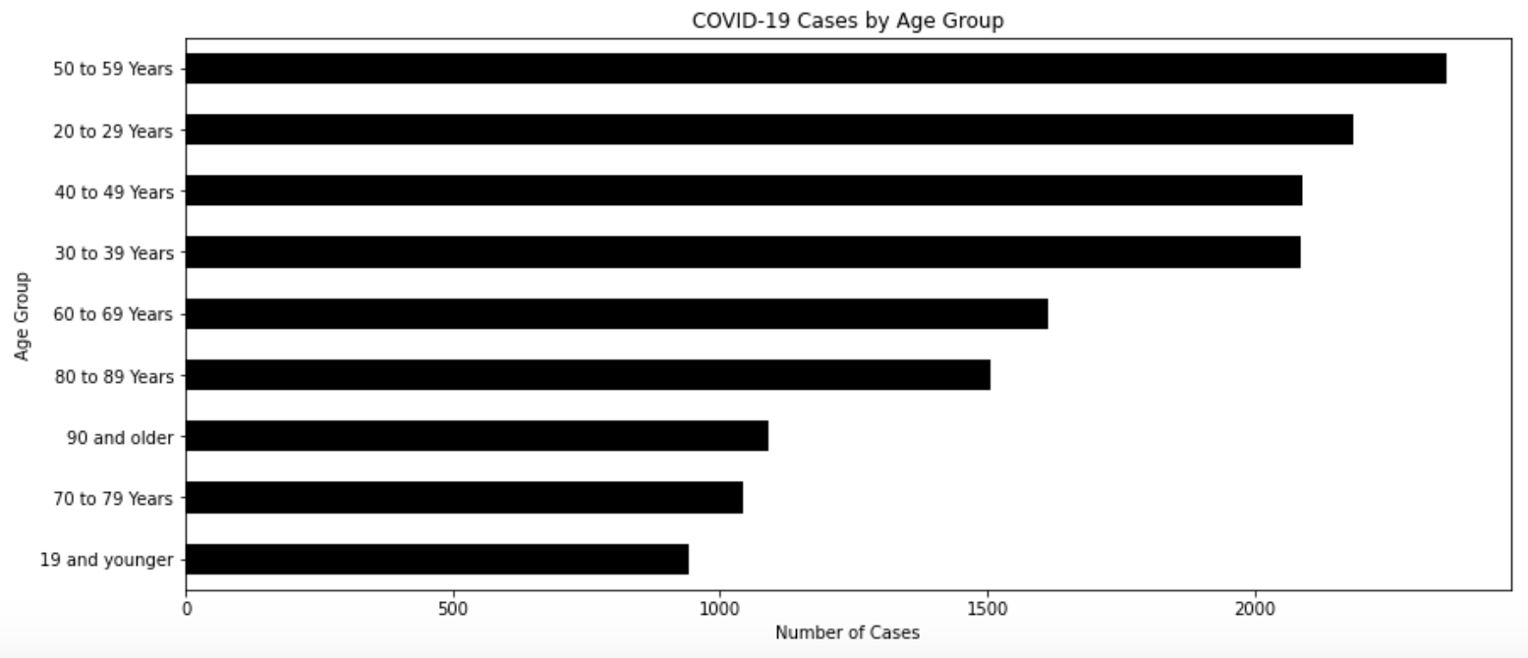

The gender, age group, and case outcome was visualized through a multi-plot grid to reveal insights.

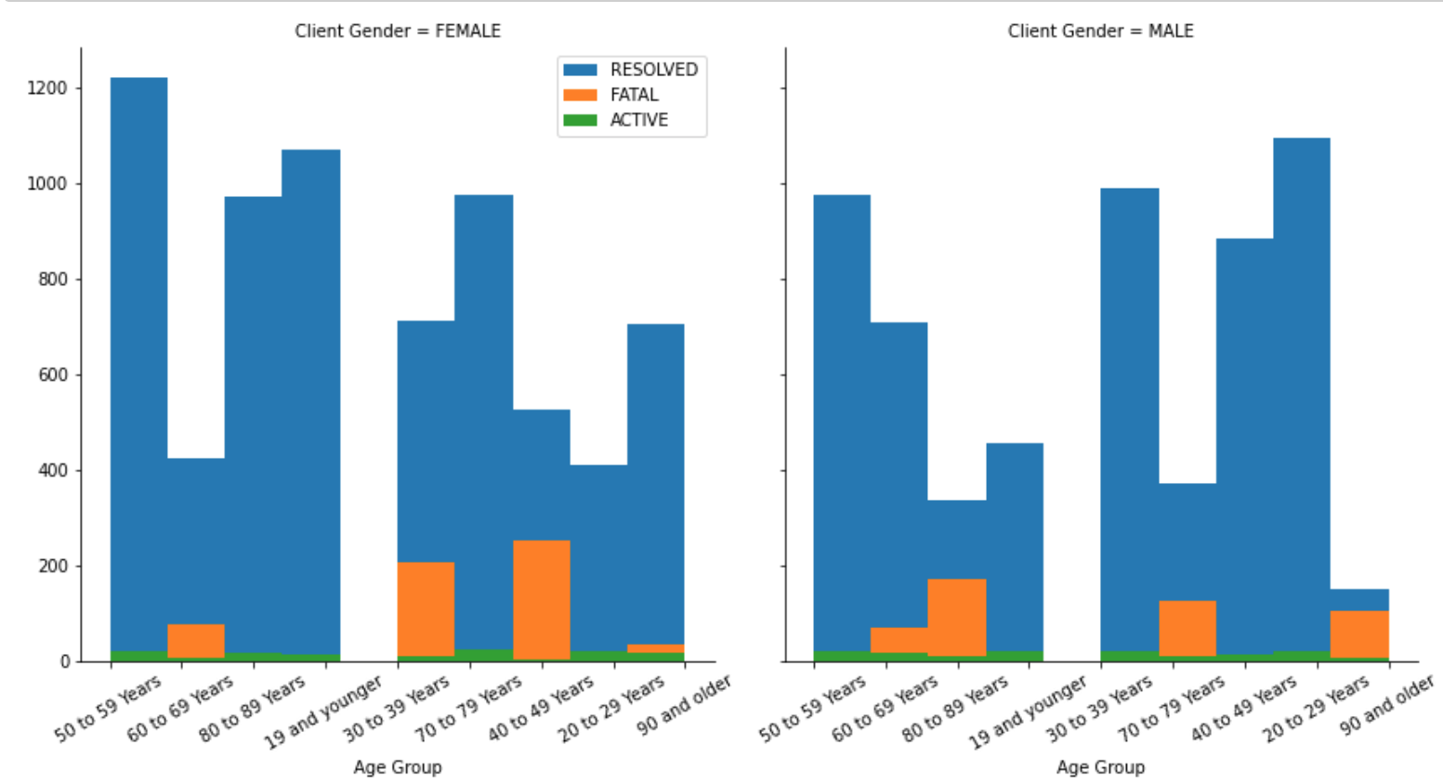As evident from the plot above, females had a higher proportion of fatal cases in comparison to males. The age groups with fatal cases were 30 to 39, 40 to 49, 60 to 69, and 90 and older in females. The age groups between 60 to 69, 80 to 89, 70 to 79, and 90 and older had fatal cases in males.

A data frame was created for total number of cases by neighbourhood. The top ten neighbourhood with the highest number of cases is highlighted below.

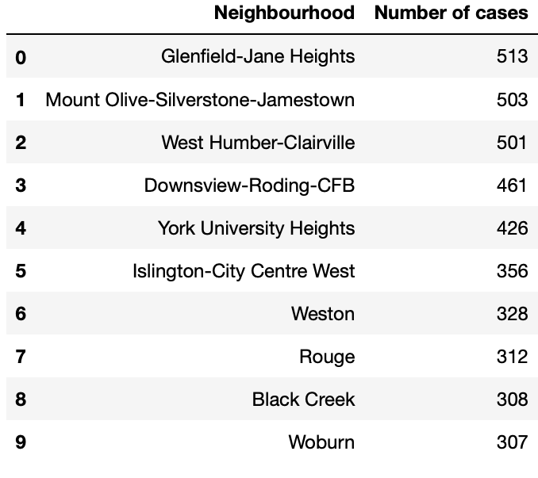

**4. Discussion**

There could be more venues as the foursquare API only gives venues based on the geographical coordinates, set limit, and the radius. The number of venues could be increased by increasing the radius, limit, and changing the latitude and longitude values.

As the crime data was cleaned to remove rows with missing/unassigned values, the total number of crimes could vary. Another thing to consider is that there could be crime occurrences that might go unreported or improperly documented. So the actual number of crimes could be higher. For more precise studies, the data set can be expanded and could be further enhanced for more specialized analysis.

The COVID-19 cases data was obtained on August 15, 2020. As the COVID-19 situation is developing, it is possible that the number of cases could increase. Another thing to note is that although the current data does indicate that females have a higher number of cases in comparison to men, this could be due to several reasons. Perhaps, it is possible that there could be a smaller percentage of men that get tested in comparison to females. A more thorough study can be done to determine more specific reasons for this disparity.

**5. Conclusion**

Overall, the venues, crime, school locations, and COVID data analysis for the city of Toronto reveals valuable insights for a wide variety of stakeholders and would be beneficial in assisting them with informed decision making. As Toronto is the economic hub of Canada and due to rising unemployment rates in Canada and elsewhere in the world, Toronto could be a melting pot for wide variety of individuals seeking a better life.

As the data for the past has suggested, over 100,000 people set their eyes towards Toronto every year. Therefore, individuals can benefit from studies, such as this one, that provide valuable insights for Toronto. It can also assist Public decision making and allow city officials with insights to better manage the city.

If you would like to conduct a study for a topic that is of value to you, feel free to get in touch with me at my personal email: [saifu_llah@hotmail.com](mailto:saifu_llah@hotmail.com).

I look forward to helping you achieve your commercial objectives and add value to your team.

Best Regards,

Saifullah Qasim

**References**

1. <https://torontoglobal.ca/Discover-Toronto-region/Toronto-region-quick-facts>
2. Toronto Borough, Postal Code, and Neighbourhood Data. <https://en.wikipedia.org/wiki/List_of_postal_codes_of_Canada:_M>
3. Longitude and Latitude, geographical coordinates of each Postal Code in Toronto. <https://cocl.us/Geospatial_data>
4. Toronto Homicide Data. <https://data.torontopolice.on.ca/datasets/homicide-1?selectedAttribute=Homicide_Type>
5. Toronto Major Crime Indicator Data. <https://data.torontopolice.on.ca/datasets/mci-2014-to-2019>
6. Toronto, COVID-19 cases data. <https://open.toronto.ca/dataset/covid-19-cases-in-toronto/>
7. Toronto School Locations Data. <https://open.toronto.ca/dataset/school-locations-all-types/>